Name___________________________________

Quick Quiz

**Unit Rate 5**

Identify the unit rate:

1. 135 miles on 6 gallons of gas 2. $y=4x$

**_________ miles per gallon unit rate =_________**

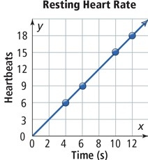

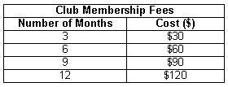3. 4.

**________**

**heartbeats per seconds**

**$_________ per month**

____________________________________________________________________________

Corrections

**Unit Rate 5**

Identify the unit rate:

1. 135 miles on 6 gallons of gas 2.

**_________ miles per gallon unit rate =_________**



3. 4.

**________**

**heartbeats per seconds**

**$_________ per month**